

EVERGREEN ANIMAL PROTECTIVE LEAGUE
FOSTER GUIDE

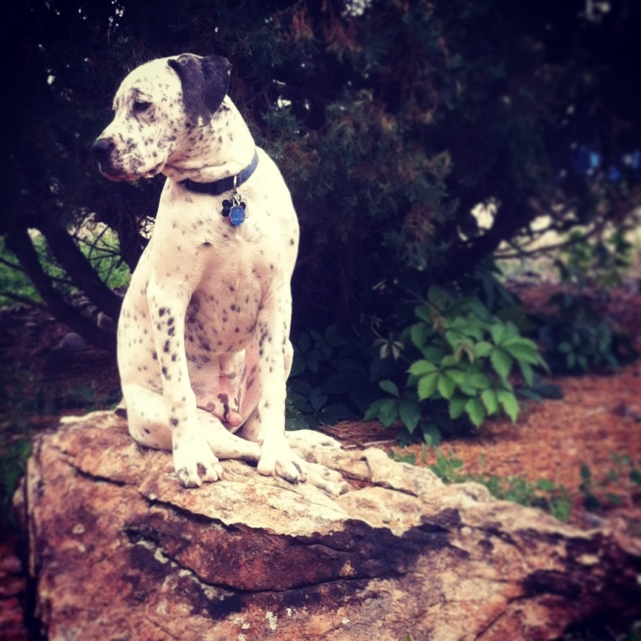
Everything you need
to know
about fostering dogs
with EAPL

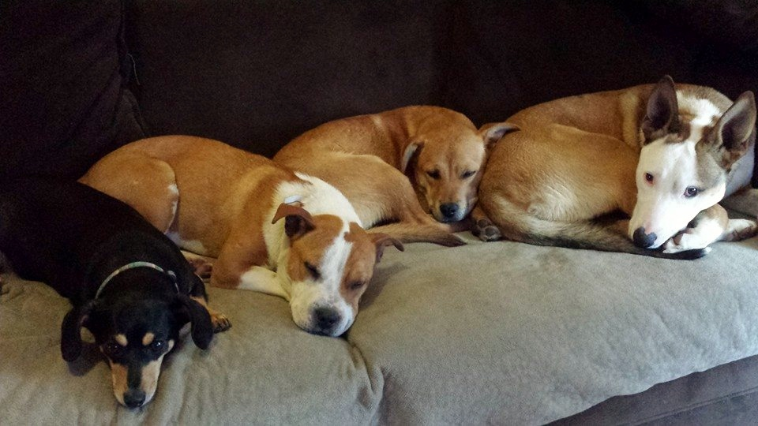

WELCOME AND INTRODUCTION
WELCOME TO THE EAPL FOSTER CARE PROGRAM!!
GENERAL CONTACT INFO:
EVERGREEN ANIMAL PROTECTIVE LEAGUE
PO BOX 2517
EVERGREEN CO 80437
PH (303) 674-6442
EM eaplevergreen@eapl.com
Website EAPL.com or EAPLwestminster.com

FOSTER FAMILY IS ASKED TO SUPPLY….
- Healthy and safe environment
- Transportation to and from anything the animal needs: vetting appointments, transport arrival, etc.
- Socialization: (family & pet interaction, leash walks, etc)
- Activities: (potty training, correcting behavior, etc)
- General interactions; (toys, noised, stairs, etc)
- Anything you wish to donate for your animals development and well being
- Lots of love and TLC!
EAPL CAN PROVIDE….
- Donated bowls, crates, collars, blankets, etc
- Dog Food
- Necessary vetting at approved EAPL vets



What does it means to be a foster?
Fostering a dog is one of many ways you can help improve the lives of homeless pets. Most fosters are well aware of the pet overpopulation problem both nationally and internationally – there are millions of dogs that wait and sadly die in shelters annually, awaiting the forever homes they truly deserve.
While shelters and rescue facilities would like to house every homeless pet, this is often impractical and impossible due to a lack of resources or space. Dogs that would otherwise be euthanized due to lack of space can be saved through caring people who are willing to open their home and hearts to a shelter pet in need.
Many homeless pets grew up in homes where they were well-loved family members. For whatever reason, these dogs find themselves homeless and alone. It is scary and stressful to go from a place where you are well loved and surrounded by your family to a place where you are surrounded by strange dogs, people, sights, and sounds.
What does it mean to “foster” a dog?
A foster home is a home (like yours!) that provides temporary shelter, care and love for pets while they are awaiting placement in a new “forever” home. Foster pets are much more likely to have successful, life-long placements in new homes when they come from a loving foster home, than when coming directly from the shelter. You will keep your foster dog until it gets new adoptive parents.
What makes a good foster home?
If you’ve had some experience with dogs before, have a basic understanding of their needs and a touch of common sense... you’re a good foster candidate! Our dogs are looking for a little love, walks, meals, and a safe place. If you think you can give this to a dog, you should consider fostering.
What does fostering a dog involve?
When you foster, you agree to take a homeless dog into your home and give him or her love, care and attention, either for a predetermined period of time or until the dog is adopted.
Why does EAPL need foster homes?
There are many reasons a dog might need foster care. Some of the most common include:
- EAPL doesn’t have a physical shelter and depends on foster homes to care for dogs until suitable homes are found.
- A puppy is too young to be adopted and needs a safe place to stay until he or she is old enough to go to a forever home.
- A dog is recovering from surgery, illness or injury and needs a safe place to recuperate.
- A dog has not lived in a home before or has not had much contact with people and needs to be socialized.
Why should I foster a dog?
Fostering a dog is one of the most rewarding experiences you can have (other than adopting, of course). By taking an animal in need temporarily into your home you’re:
- Giving your foster dog the time he needs to be ready for adoption.
- Saving your foster dog’s life
- Helping the rescue learn more about the dog so he can end up in the best home possible.
- Socializing the dog to a home environment and possibly getting him used to being around other pets and different types of people.

WHAT IS A FOSTER?

WHAT IS A RESCUE DOG
First and foremost, a rescue dog is one that needs a new home. Like people, rescue dogs come from a wide variety of backgrounds and have varying needs. Some come from loving homes that can no longer keep their cherished pets. Reasons include an owner who dies or must go into a nursing facility, families that are forced to make a lifestyle change, such as a move overseas or into another home where pets are not permitted, or animals that are given up due to divorce. Others are given up because the owners were unprepared for the lifestyle requirements of the breed or they did not spend the time to properly train their dogs.
Most of the dogs in EAPL’s program were obtained from animal shelters or found as homeless strays. These animals are usually in danger of being euthanized and we are their last chance. The shelter does a variety of test of their behavior, if they are good with people and other animals. However, they are usually coming from a bad situation and have endured lots of neglect and are learning how to be a “normal” dog again when they come to us. They will require lots of TLC from their foster family.
WHAT IS A RESCUE DOG & WHAT TO EXPECT

WHAT TO EXPECT

As a foster parent, you would temporarily take an animal into your home and give us a character assessment
of the animal. EAPL pays for needed medical attention and food. If you feel the animal needs anything
special, we usually have donated items we can provide. However, you are more than welcome to donate
any supplies your animal needs, and it would (of course) be much appreciated. If the animal is not house
trained, we hope that you will do some training to help make the pet more adoptable. Most of the animals
will be coming from shelters. We ask that you be patient with them and try to help them transition to their
new role as "homeless pet" in any way needed. Help us try to figure out what they need to move forward
and together we can make it happen. EAPL will be with you every step of the way.

If you are interested in fostering dogs, you can tell us the size, type, age, etc. and we will try to match you to
your preference. Maybe you prefer puppies; we'd like you to specify big or tiny puppies.

There is no guarantee on how long an animal will be with you, but we do everything within our power to get
the animal into a permanent home. We advertise/list our pets on www.PetFinder.com along with 30 other
national websites. We utilize four local social network sites. We also have four bulletin boards around town
on which we post photos of the animals that we have available for adoption along with a small write-up about the animal. Weather permitting; we generally host 2+ adoption events per month and more if possible.

We ask that you truly think about fostering before you decide to foster. Most of the time, almost 100%, when we bring in an animal to a foster home, we have NO OTHER place to put it. We will sometimes have a kennel open at a boarding facility, but we don't want the dog to sit in a kennel until it's adopted either. Please keep in mind that it will take us some time to find another foster home.

We will also need your help getting your pup where it needs to go. We hope that you will be able to pick him up from his shelter or transport and take him to any vetting appointments necessary, along with meeting adopters in hopes of finding his forever family

EAPL FINANCIAL RESPONSIBILITY RULES/RESTRICTIONS
EAPL will provide your foster animal will everything we can to make your experience as easy and as rewarding as possible.
We ask that the foster family be responsible for supplying
- Healthy and safe environment
- Transportation to and from anything the animal needs:
vetting appointments, transport arrival, etc.
- Socialization: (family & pet interaction, leash walks)
- Activities: (potty training, correcting behavior, etc)
- General interactions; (toys, noised, stairs, etc)
- Anything you wish to donate for your animals
development and well being
(food, toys, collars, sweaters, etc)
- Lots of love and TLC!

EAPL will be responsible for supplying:
EAPL receives donations from wonderful supporters and are able to provide these things to our foster homes if needed. If you would like any of these donated items, please contact Jackie at JBeapl@aol.com for more info.
- Crates
- Dog food
- Blankets
- Dog beds
- Bowls

EAPL will provide reimbursement for Dog Food and other supplies when needed. We are a non-profit and all funds go directly to the animals, we ask that if you can use donated food first, please do. If you would like to buy your foster’s food as a donation to the rescue, that would be greatly appreciated as well. If you do need reimbursement, you will need to mail in your receipts to EAPL. Please contact your foster rep for any special requests and we ask that you be mindful of the expenses and keep costs as low as possible.
You can mail your receipts to
Cyndi Rice
P.O. Box 3343
Evergreen, CO 80437

*Please include your full name, return address, and name of your foster pet with your receipt.

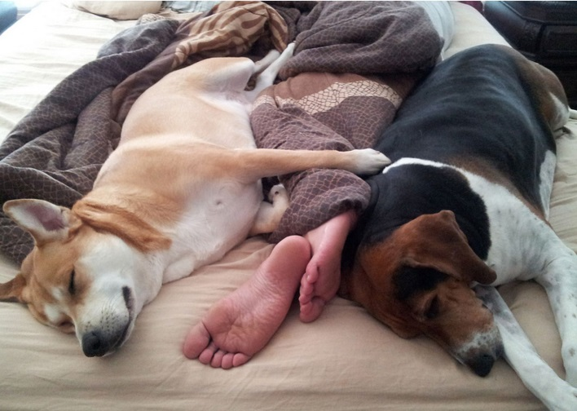



EAPL will provide all necessary medical care at our approved vets. Your animal may need vaccines, altered, basic medical care, or in unexpected illness/injury cases.
*ALL VETTING WILL REQUIRES prior authorization from an EAPL representative.
Please contact
Jackie at JBeapl@aol.com or Cathleen at cathleentimmons@gmail.com for prior approval and instructions.
If an emergency and you cannot get ahold of anyone, please call the EAPL main line at (303) 674-6442
APPROVED VETS (we are always adding more just ask Cathleen or Jackie when you call)
- Brekke Veterinary Clinic 856 W. Happy Canyon Rd. Suite 120 Castle Rock, CO 80108 (303)474-4260

- Spay2day (spay/neuter) 1864 S Wadsworth Blvd #2, Lakewood, CO 80232 (303) 984-7729

- Downtown Animal Care Center 1041 Galapago St, Denver, CO 80204 (303) 595-3561

- Clear Creek Animal Hospital 4980 Kipling St, Wheat Ridge, CO 80033 (303) 424-1314

- Lookout Mountain Animal Hospital 24059 U.S. 40, Golden, CO 80401 (303) 526-4141

- Lakeside Animal Hospital 4243 Harlan St, Wheat Ridge, CO 80033 (303) 955-4576

- Aspen Grove Vet 2633 S College Ave, Fort Collins, CO 80525 (970) 416-0232

- Planned Pethood Plus 4595 Harlan St, Wheat Ridge, CO 80033 (303) 433-3291

- Genesse Veterinary Hospital 25948 Genesee Trail Rd, Golden, Co 80401 (303) 526-1655

- Kittredge Animal Clinic 26390 CO-74, Kittredge, CO 80457 (303) 674-6773

- Fort Collins (spay/neuter) 2321 E Mulberry St # 12A, Fort Collins, CO 80524 970-484-1861

VET CARE



YOUR ROLE HELPING YOUR FOSTER FIND A FOREVER HOME
You can help your foster find that forever home they have been searching for
Once your foster is home, we need your input!! You are the one who will know the animal the best and spend the most time with him.
WEBSITE
We ask that you send us as many cute, clear, and well lit pictures of the animal as you can – so we can post him on our website. He will be listed on our internal websites as well as our 30+ external ones such as Petfinder, Adopt-a-pet, PetHarbor, etc. We also ask that you tell us everything you can about him to create an accurate bio such as
- How he is with your other animals
- How he reacts to strangers
- How he is with the children
- Does he have any basic training
- Is he potty trained
- How does he do in the crate
- What are his favorite things to do
ADOPTION EVENTS
We also have lots of adoption events where you can bring him to meet potential adopters first hand! We will email you on upcoming events and you can always keep updated on our “UPCOMING EVENTS” page at http://eapl.com/upcoming_events.html


Wilbur is an adorable 9 week old Hound/Bulldog mix puppy. He loves to play, but would rather couch cuddle with his people than romp around with his rambunctious siblings. He is the sweetest cutest guy and such a little lover.

GETTING READY FOR A FOSTER DOG
After being approved as a qualified foster home, but before you bring a new foster dog home, we suggest you prepare yourself, your family, and your home for a new canine companion.

WHERE TO KEEP YOUR FOSTER DOG
Planning where to keep your dog before you bring your dog home will make the entire process easier for everyone. When you first bring a foster dog home, you’ll want to confine them to a single room such as a kitchen or family room. The room should not be an isolated room, but a room where you spend a large part of your day or evenings, as dogs are pack animals and want to be with you. This room is especially important when you are at work or away from the house, as it will be the new environment in which they need time to become familiar and comfortable.
Use a baby gate to block of entrances to other rooms. By keeping the dog in one room, you’re helping to prevent accidents that may occur because of stress or adjusting to your routine. (Even a housetrained dog may have an accident or two during the adjustment period). For dogs that are not housetrained, keeping them in one room will help start this important training as you must be able to monitor their activities
THE DO’S
- Do keep your foster dog indoors in a location with a crate available.
- Do keep your foster dog in a warm/cool and dry location.
- Do keep your foster dog on a leash at all times when outdoors unless in your secured fenced yard. When in a secured yard, you must supervise him at all times. It is very common for a shelter dog to try and escape so always supervise your dog.
THE DONT’S
- Do not place your foster dog around other strange dogs as we do not often know the dog’s past history.
- Do not allow your foster dog outdoors unless supervised by an adult
- Do not take your foster dog to an off leash park.
- Do not let your foster dog run off leash in a public environment

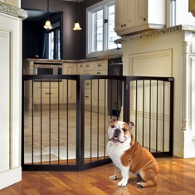


HOW TO DOG-PROOF A ROOM
Walk into the room in which you plan to confine your foster and ask yourself:
- Is there room for the crate?
- Is there quick access to the outside or bathroom breaks?
- Is there anything that can be chewed, such as drapes, a couch, and cords?
- Are any exposed electrical wires?
- Is there anywhere the dog can hide? Will you be able to get the dog out if hidden?
- Are there coffee tables with objects that can be knocked off by wagging tail?
- Are there plants in the room? If so, check the list of toxic plants to ensure they are safe
- Where will I set up the crate once all hazards are removed?
- Is the crate in a quiet, low-traffic area of the room?
- Is there a blanket in the crate to train your foster dog that it’s his bed?
INTRODUCING YOUR DOG TO YOUR FOSTER DOG
What to do once you are home with your foster dog
- If possible, go for a walk around your neighborhood with both dogs and two handlers. Walk the dogs side by side on leashes and allow them to sniff one another and become familiar with each other.
- Do give your own dog LOTS of love and praise.
- Do leave leashes on the dogs when you are in the home, so that you can get immediate control if needed. You may only need to do this for a short time.
- Do talk normally. Letting the dogs know that you are fine, they are fine, and everything is fine!
- Be patient and go slowly with your foster dog as they may have been through a stressful surgery, abusive situation, or a lot of recent changes.
- Don’t leave your foster dog unattended with your resident dog. Even if they seem to get along well in your presence, you should separate the dogs when you leave your house. After a week, you may determine that this is no longer necessary, but be sure to always remove all toys, food, chews, and start slowly.

BRINGING YOUR FOSTER DOG HOME

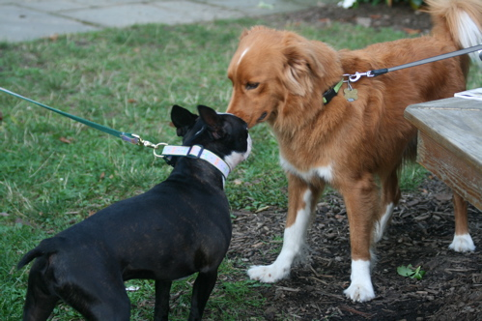

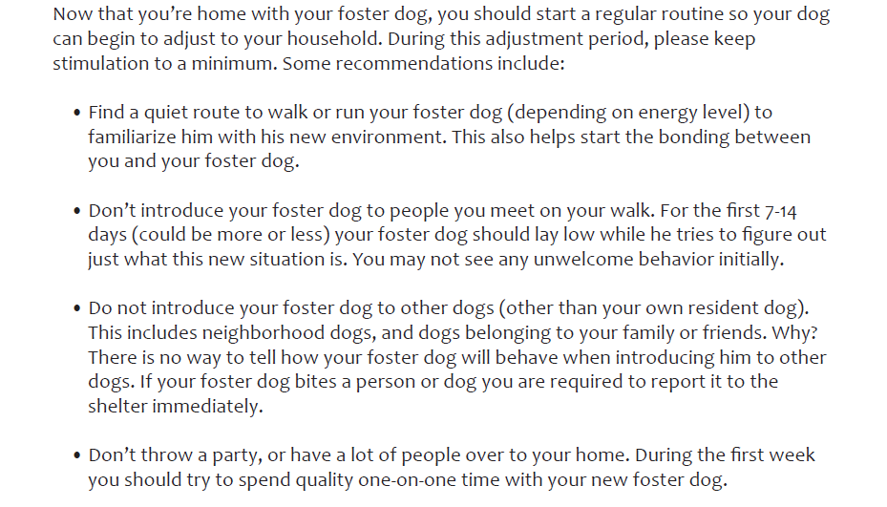

YOUR FIRST WEEK

CARING FOR YOUR FOSTER DOG
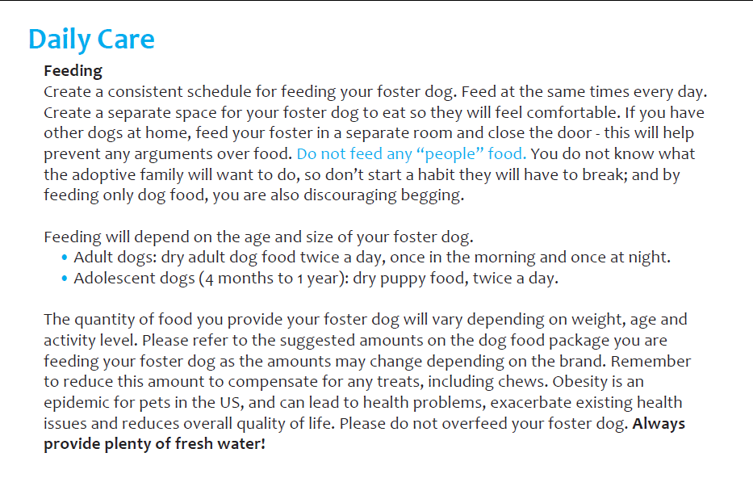
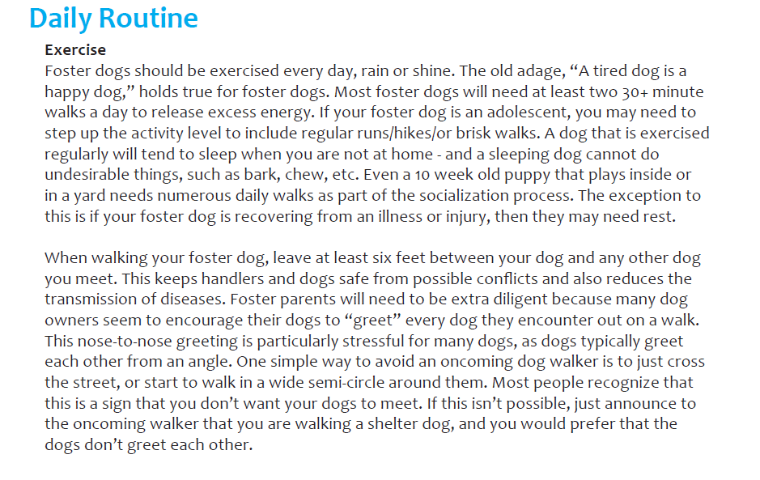



CARING FOR YOUR FOSTER DOG
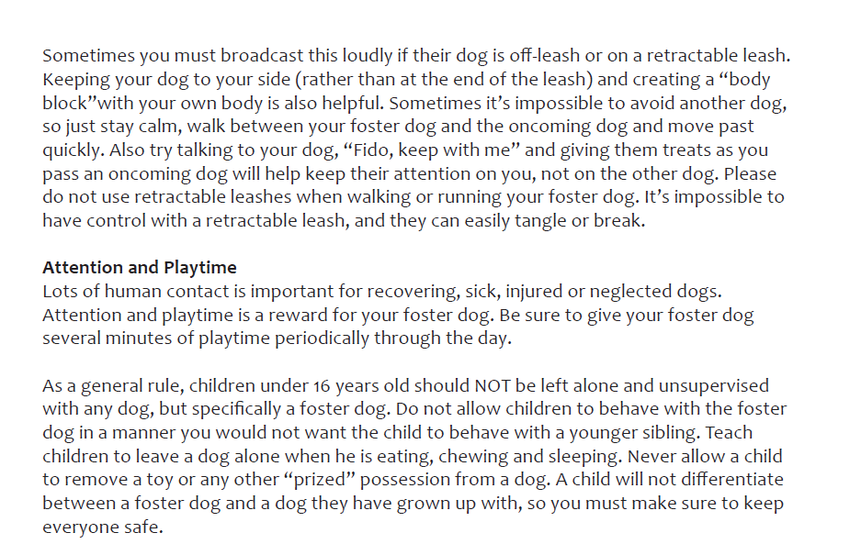



HOUSETRAINING
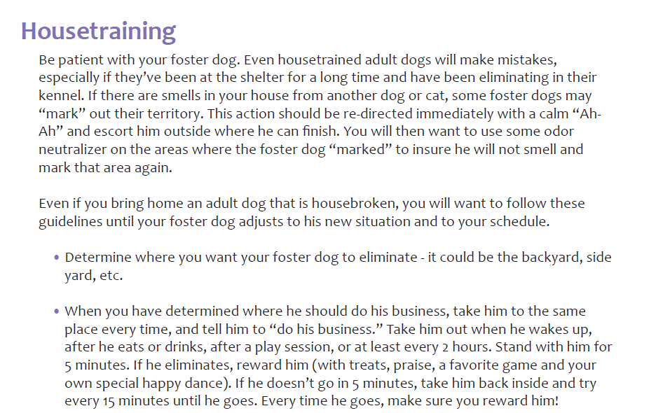
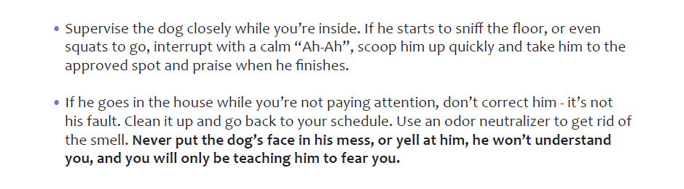

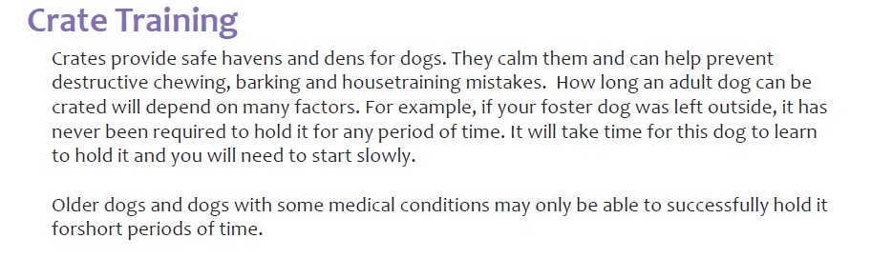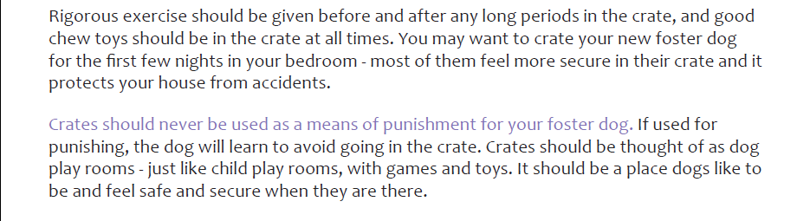
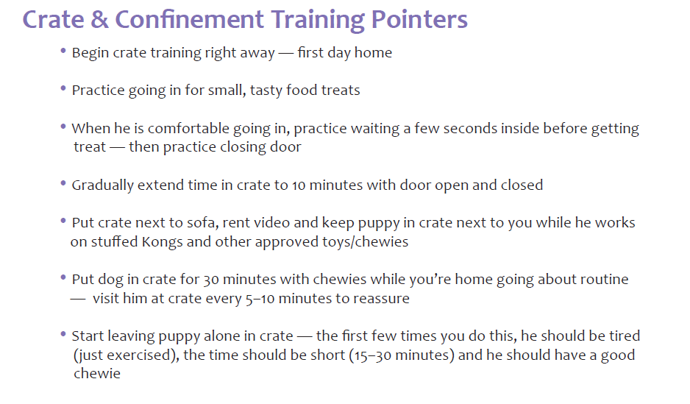
CRATE TRAINING

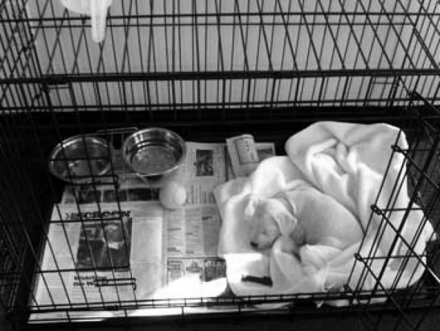

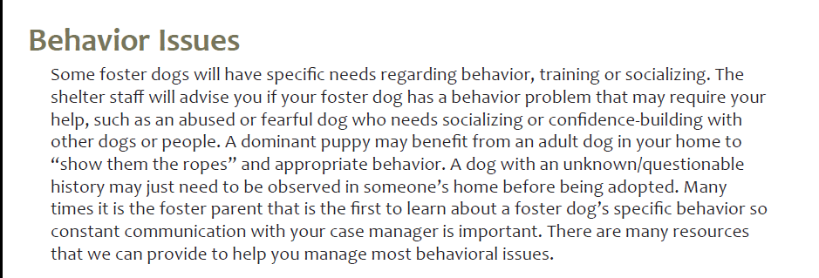
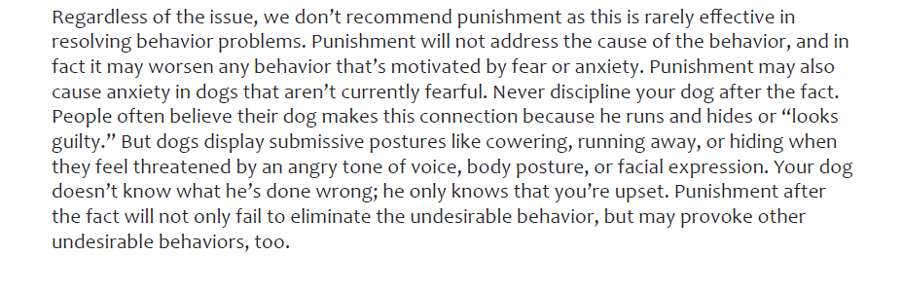
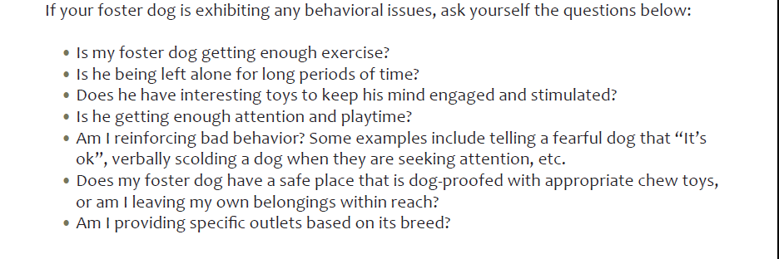
BEHAVIOUR ISSUES

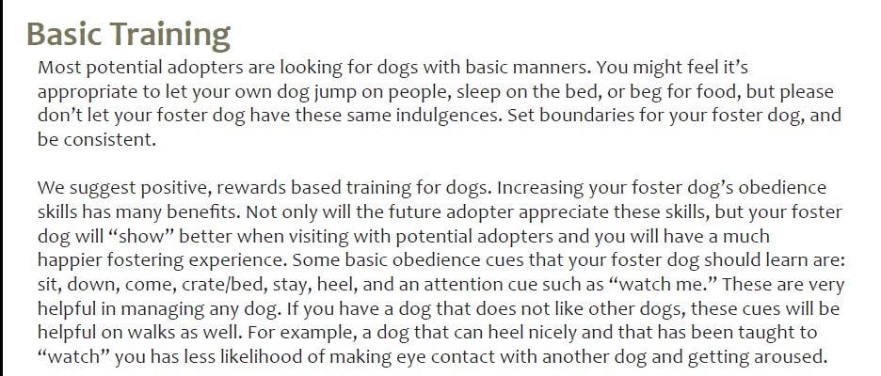
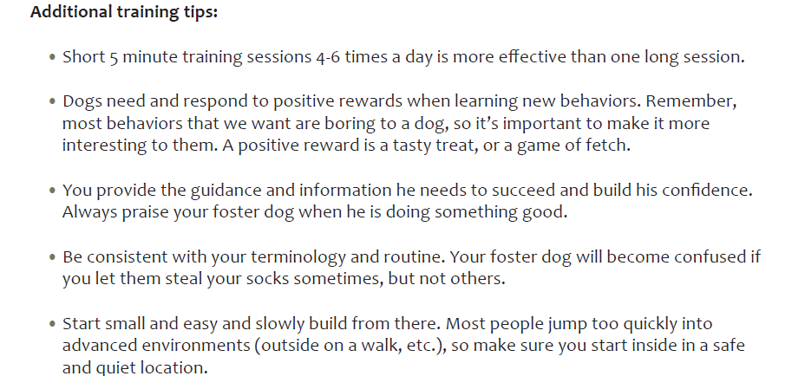
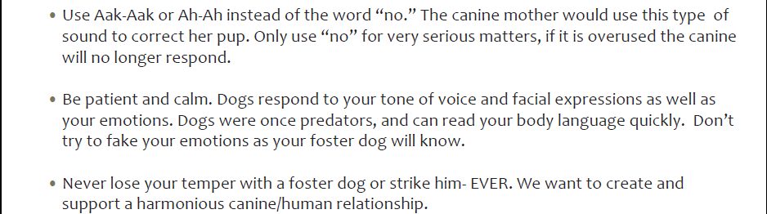
BASIC TRAINING

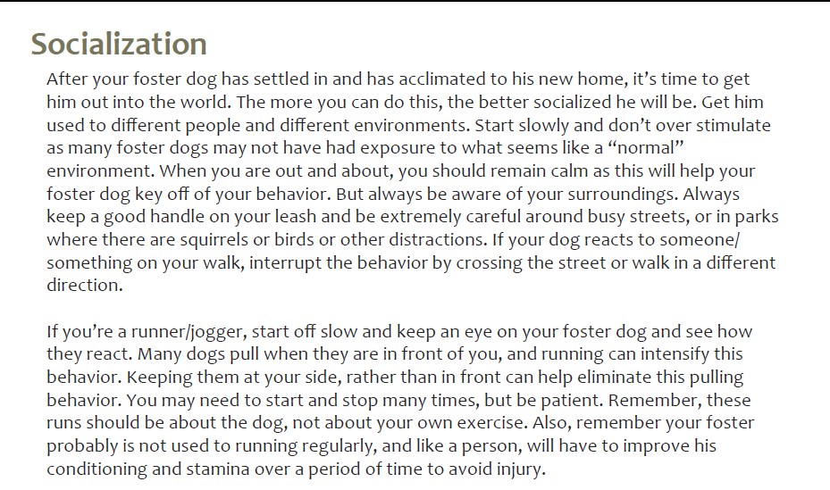
SOCIALIZATION

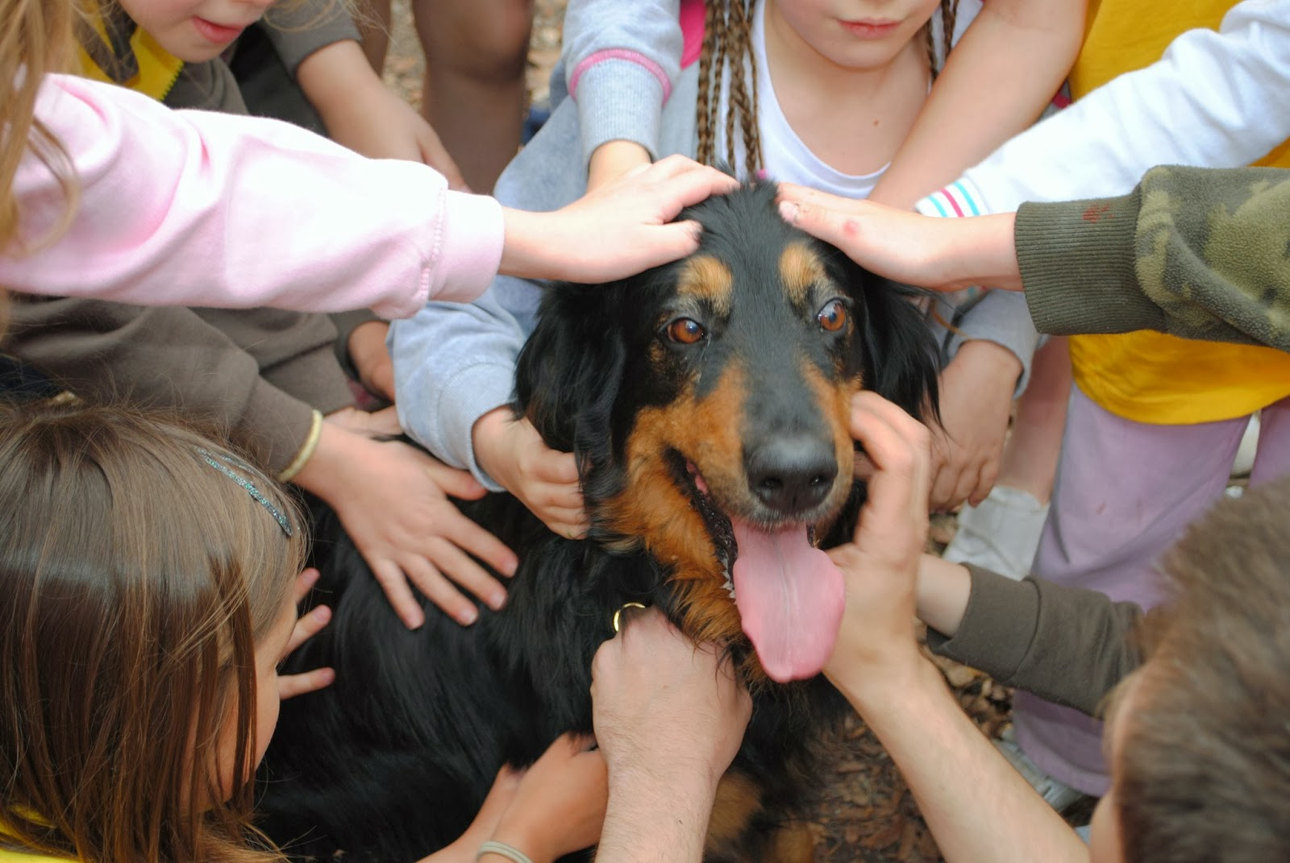

- EAPL will receive an application via the website for your animal.

- We will do an initial check on the applicant and send the application to the foster parent for review

- If the foster parent agrees it to be a good fit, then we will move forward with the potential adopter meeting the animal. (We recommend doing the meeting on neutral territory and if you are comfortable your home, or their home or at an event)

- If everyone agrees it to be a good match, the adopter will sign an adoption contract and include a spay/neuter deposit along with the adoption fee of the animal.

Adult dogs $125 (1yr and older) - includes Distemper/Parvo vaccine and Spay/Neuter.

Total of $250 - Puppies $200 (under 1yr) - includes age appropriate Distemper/Parvo vaccines and Spay/Neuter at our assigned vet. Spay/Neuter deposit of $50 is required

if not altered at time of adoption due to age. Puppy proof of spay/neuter is due to EAPL at 16-20 weeks old. You will be issued a pre-paid certificate to be redeemed at Spay2day in Lakewood.

- EAPL will keep in contact with the adopter and make sure things are going well, if so, we will email out the spay/neuter certtificate once they know their dog/puppy is a keeper.

- The foster will mail the signed adoption agreement along with the adoption fee + spay neuter deposit (as needed) check to:
Cathleen Timmons
10754 Beas Drive
Conifer CO 80433

ADOPTION PROCESS


THEN YOUR FOSTER IS ON HIS WAY TO HIS HAPPY ENDING!

